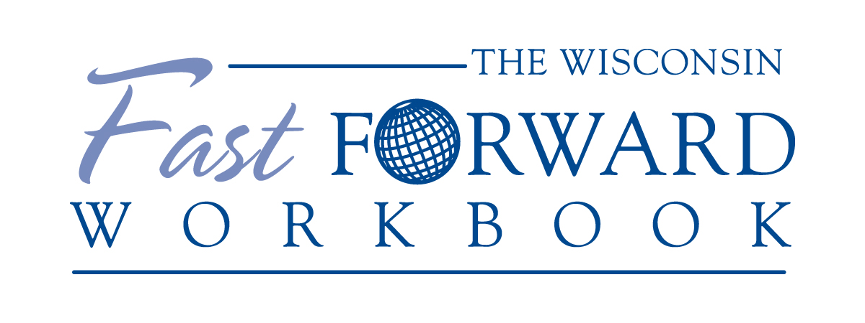

To be used in conjunction with the
Baldrige Excellence Builder
Intent to apply form is included in this packet
March 2020

2909 Landmark Place, Suite 300 Madison, WI 53713
(608) 663-5300
www.wisquality.org

The Wisconsin Fast Forward Review Process

Examination Team Review and Feedback Report | Upon receipt of your organization’s application, the WFA Examiner Team thoroughly reviews your application and prepares a written Feedback Report, which goes through additional review by the WFA Panel of Judges and staff. This process will take approximately six to eight weeks. The Feedback Report will include strengths and opportunities for improvement for each Criteria Item.
Site Visit | Members of the examiner team will conduct a one-day site visit and action planning session. This may be a virtual site visit due to COVID-19 considerations.

The Wisconsin Fast Forward Application

Organizational Profile | Applicants should submit their responses to organizational profile questions that set the context for the review of their application. This section is typically five pages. A Glossary and Organization chart does not count towards page limit.
Responses to Overall Criteria Requirements | Applicants should response to the OVERALL requirements found in the Baldrige Excellence Builder. This section is limited to 35 pages. You may have more or fewer pages. Refer to page 3 of the Excellence Builder for tips. A glossary of key terms begins on page 16. Baldrige Core Values are outlined on page 4.

Importance of Beginning with Your Organizational Profile
Your Organizational Profile is critically important because:
- It is the most appropriate starting point for self-assessment and for writing an application.
- It helps you identify potential gaps in key information and focus on key performance requirements and results.
- It is used by the Examiners and Judges in application review to understand your organization and what you consider important. You will be assessed using the Criteria requirements in relation to your organization’s environment, relationships, influences, and challenges as presented in your Organizational Profile.
- It also may be used by itself for an initial self-assessment. If you identify topics for which conflicting, little, or no information is available, it is possible that the Organizational Profile can serve as your complete assessment, and you can use these topics for action planning.

Organizational Profile

The Organizational Profile is a snapshot of your organization, the KEY influences on HOW you operate and the KEY challenges you face. Feel free to use lists or charts as you prepare your responses. This section should be around 5-6 pages, typically.

P.1 Organizational Description: What are your key organizational characteristics?

- Organizational Environment

  - Product Offerings What are your main product offerings*? What is the relative importance of each to your success? What mechanisms do you use to deliver your products?

  - Mission, Vision, Values and Culture What are your mission, vision, and values? Other than VALUES, what are the characteristics of your organizational culture, if any? What are your organization’s core competencies, and what is their relationship to your mission?

  - Workforce Profile What is your workforce profile? What recent changes have you experienced in workforce composition or your needs with regard to your workforce? What are
    - your workforce or employee groups and segments;
    - the educational requirements for different employee groups and SEGMENTS;
    - the key drivers that engage them;
    - your organized bargaining units (union representation), if any, and
    - your special health and safety requirements, if any?

  - Assets What are your major facilities, equipment, technologies, and intellectual property?

  - Regulatory Requirements What are your KEY applicable occupational health and safety regulations; accreditation, certification, or registration requirements; industry standards; and environmental, financial, and product regulations?

- Organizational Relationships

  - Organizational Structure What are your organizational leadership structure and governance structure? What structures and mechanisms make up your organization’s LEADERSHIP SYSTEM? What are the reporting relationships among your governance board, senior leaders, and parent organization, as appropriate?

(Continued on the next page)

Terms in small caps are defined in the Glossary of Key Terms towards the end of this document.

**For health care organizations, “customers” are the users of your health care services (e.g., patients, families, insurers, and other third-party payors).
For education organizations, “customers” are the users of your educational programs and services (e.g., students and parents).

- customers** and stakeholders What are your key market segments, customer groups, and stakeholder groups, as appropriate? What are their key requirements and expectations for your products, customer support services, and operations, including any differences among the groups?

- Suppliers, Partners and COLLABORATORS What are your key types of suppliers, partners, and COLLABORATORS? What role do they play in producing and delivering your KEY products and CUSTOMER support services, and in enhancing your competitiveness? What role do they play in contributing and implementing innovations in your organization? What are your key supply-network requirements?

P.2 Organizational Situation: What is your organization’s strategic situation?

- Competitive Environment

  - Competitive Position What are your relative size and growth in your industry or the markets you serve? How many and what types of competitors do you have?

  - Competitiveness Changes What key changes, if any, are affecting your competitive situation, including changes that create opportunities for innovation and collaboration, as appropriate?

  - Comparative Data What key sources of comparative and competitive data are available from within your industry? What key sources of comparative data are available from outside your industry? What limitations, if any, affect your ability to obtain or use these data?

- Strategic Context

What are your key strategic challenges and ADVANTAGES?

- Performance Improvement System

What is your performance improvement system, including your processes for evaluation and improvement of key organizational projects and processes?

Terms in small caps are defined in the Glossary of Key Terms towards the end of this document.

The Seven Criteria Categories of Performance Excellence

Respond to the Overall Requirements of the Baldrige Criteria found in the Baldrige Excellence Builder. Tips for answering questions in categories 1 – 7 can be found on page 3 of the booklet. Focus on your key processes in Categories 1-6. You may include narrative, lists, tables, and other related graphics in your response.
Typically, applicants will devote 2 to 3 pages per Category response in Categories 1-6. Your response to Category 7, Results, may require at least 3 or 4 pages. We are most interested in what you are doing, not how you are writing about it. You will be well served by focusing on the KEY processes and results within your organization.
Please note that it is not necessary to discuss specific results in Categories 1–6 since all results can be listed in Category 7.

1. Leadership
The Leadership Category examines how your organization’s senior leaders’ personal actions guide and sustain your organization. Also examined are your organization’s governance and how your organization fulfills its legal, ethical, and societal responsibilities and supports its key communities.

- Senior Leadership: How do your senior leaders lead the organization?

  - how do senior leaders set your organization’s vision and values?

  - how do senior leaders’ actions demonstrate their commitment to legal and ethical behavior?

(3) how do senior leaders communicate with and engage the entire workforce, key Partners and key customers?

- how do senior leaders’ actions create an environment for success now and in the future?

- how do senior leaders create a focus on action that will achieve the organization’s mission?

- Governance and Societal Responsibilities: How do you govern your organization and fulfill your societal responsibilities?

  - how does your organization ensure responsible governance?

  - how do you evaluate the performance of your senior leaders and your governance board?

  - how do you address and anticipate legal, regulatory, and community concerns with your products and operations?

  - how do you promote and ensure ethical behavior in all interactions?

  - how do you consider societal well-being and benefit as part of your strategy and daily operations?

  - how do you actively support and strengthen your key communities?

Terms in small caps are defined in the Glossary of Key Terms towards the end of this document.

2. Strategic Planning
The Strategic Planning Category examines how your organization develops strategic objectives and action plans. Also examined are how your chosen strategic objectives and action plans are deployed and changed if circumstances require, and how progress is measured.

- Strategy Development: How do you develop your strategy?

  - how do you conduct your strategic planning?

  - how does your strategy development process stimulate and incorporate innovation?

  - how do you collect and analyze relevant data and develop information for your strategic planning process?

  - how do you decide which key processes will be accomplished by your workforce and which by external suppliers and partners and collaborators?

  - What are your organization’s key strategic objectives and timetable for achieving them?

  - how do your strategic objectives achieve appropriate balance among varying and potentially competing organizational needs?

- Strategy Implementation: How do you implement your strategy?

  - What are your key short- and longer-term action plans?

  - how do you deploy your action plans?

  - how do you ensure that financial and other resources are available to support the achievement of your action plans while you meet current obligations?

  - What are your key workforce plans to support your short- and longer-term strategic
objectives and action plans?

- What key performance measures or indicators do you use to track the achievement and effectiveness of your action plans?

- For these key performance measures or indicators, what are your performance projections for your short- and longer-term planning horizons?

- How do you establish and implement modified action plans if circumstances require a shift in plans and rapid execution of new plans?

Terms in small caps are defined in the Glossary of Key Terms towards the end of this document.

3. Customer Focus
The Customer Focus Category examines how your organization engages its customers for long-term marketplace success. This engagement strategy includes how your organization builds a customer-focused culture. Also examined is how your organization listens to the voice of its customers and uses this information to improve and identify opportunities for innovation.

- Voice of the Customer: How do you listen to your customers and determine product and services to meet their needs?

  - how do you listen to, interact with, and observe customers* to obtain actionable information?

  - how do you listen to potential customers to obtain actionable information?

  - how do you determine your customer groups and market segments?
  - how do you determine product offerings?

- Customer Engagement: How do you build relationships with customers and determine satisfaction and engagement?

  - how do you build and manage customer relationships?
  - how do you enable customers to seek information and support?

  - how do you manage customer complaints?
  - how do you determine customer satisfaction, dissatisfaction, and engagement?

  - how do you obtain information on customers’ satisfaction with your organization relative to other organizations?

  - how do you use voice-of-the-customer and market data and information?

Terms in small caps are defined in the Glossary of Key Terms towards the end of this document.

*For health care organizations, “customers” are the users of your health care services (e.g., patients, families, insurers, and other third-party payors).

For education organizations, “customers” are the users of your educational programs and services (e.g., students and parents).

4. Measurement, Analysis, and Knowledge Management
The Measurement, Analysis, and Knowledge Management Category examines how your organization selects, gathers, analyzes, manages, and improves its data, information, and knowledge assets and how it manages its information technology. The Category also examines how your organization reviews and uses reviews to improve its performance.

- Measurement, Analysis, and Improvement of Organizational Performance: How do you measure, analyze, and then improve organizational performance?

  - how do you track data and information on daily operations and overall organizational performance?

  - how do you select comparative data and information to support fact-based decision making?

  - how do you ensure that your performance measurement system can respond to rapid or unexpected organizational or external changes?

  - how do you review your organization’s performance and capabilities?

  - how do you project your organization’s future performance?

  - how do you use findings from performance reviews (addressed in question 5) to develop priorities for continuous improvement and opportunities for innovation?

- Information and Knowledge Management: How do you manage your information and your organizational knowledge assets?

  - how do you verify and ensure the quality of organizational data and information?

  - how do you ensure the availability of organizational data and information?

  - how do you build and manage organizational knowledge?

  - how do you share best practices in your organization?

  - how do you use your knowledge and resources to embed learning in the way your organization operates?

Terms in small caps are defined in the Glossary of Key Terms towards the end of this document.

5. Workforce
The Workforce Focus Category examines how your organization engages, manages, and develops your workforce to utilize its full potential in alignment with your organization’s overall mission, strategy, and action plans. The Category examines your ability to assess workforce capability and capacity needs and to build a workforce environment conducive to high performance.

- Workforce Environment: How do you build an effective and supportive workforce environment?

  - how do you assess your workforce capability and capacity needs?

  - how do you recruit, hire, place, and onboard new workforce members?

  - how do you prepare your workforce for changing capability and capacity needs?

  - how do you organize and manage your workforce?

  - how do you ensure workplace health, security, and accessibility for the workforce?

  - how do you support your workforce via services, benefits, and policies?

- Workforce Engagement: How do you engage your workforce for retention and high-performance?

  - how do you determine the key drivers of workforce engagement?

  - how do you assess workforce engagement?

  - how do you foster an organizational culture that is characterized by open communication, high performance, and an engaged workforce?

  - how does your workforce performance management system support high performance?

- how does your learning and development system support the organization’s needs and the personal development of your workforce members and your organization’s needs?

- how do you evaluate the effectiveness and efficiency of your learning and development system?

- how do you manage career development for your workforce and your future leaders?

Terms in small caps are defined in the Glossary of Key Terms towards the end of this document.

6. Operations
The Operations Focus category examines how your organization designs, manages, and improves its key work systems and work processes to deliver customer value and achieve organizational success and sustainability. Also examined is your readiness for emergencies.

- Work Processes: How do you design, manage, and improve your key products and work processes?

  - how do you determine key product* and work process requirements?

  - What are your organization’s key work processes?

  - how do you design your products and work processes to meet requirements?

  - how does your day-to-day operation of work processes ensure that they meet key process requirements?

  - how do you determine your key support processes?

  - how do you improve your work processes to improve products and performance, enhance your core competencies, and reduce variability?

  - how do you manage your supply network?

  - how do you pursue your opportunities for innovation?

- Operational Effectiveness: How do you ensure effective management of your operations?

  - how do you manage the cost, efficiency and effectiveness of your operations?

  - how do you ensure the security and cybersecurity of sensitive or privileged data and information?

  - how do you provide a safe operating environment?

  - how do you ensure that your organization is prepared for disasters or emergencies?

Terms in small caps are defined in the Glossary of Key Terms towards the end of this document.

*For health care organizations, “products” are health care services.
For education organizations, “products” are educational programs and services.
See www.nist.gov/baldrige/publications/baldrige-excellence-framework for Baldrige frameworks tailored to the health care and education sectors.

7. Results
The Results Category examines your organization’s performance and improvement in all key areas—product and process-effectiveness outcomes, customer-focused outcomes, workforce-focused outcomes, leadership and governance outcomes, and financial and market outcomes. Performance levels are examined relative to those of competitors and other organizations with similar product offerings.

- Product and Process Results: What are your product performance and process effectiveness results?

  - What are your results for your products and your customer service processes?

  - What are your process effectiveness and efficiency results?

  - What are your safety and emergency preparedness results?

  - What are your supply-chain management results?

- Customer-Focused Results: What are your customer-focused performance results?

  - What are your customer satisfaction and dissatisfaction results?

  - What are your customer engagement results?

- Workforce-Focused Results: What are your workforce-focused performance results?

  - What are your workforce capability and capacity results?

  - What are your workforce climate results?

  - What are your workforce engagement results?

  - What are your workforce and leader development results?

Terms in small caps are defined in the Glossary of Key Terms towards the end of this document.

- Leadership and Governance Results: What are your senior leadership and governance results?

  - What are your results for senior leaders’ communication and engagement with the workforce and customers?

- What are your results for governance accountability?

- What are your legal and regulatory results?

- What are your results for ethical behavior?

- What are your results for societal responsibilities and support of your key communities?

- Financial and Market Results: What are your results for financial viability?

  - What are your financial performance results?

  - What are your marketplace performance results?

  - What are your results for the achievement of your organizational strategy and action plans?

Terms in small caps are defined in the Glossary of Key Terms towards the end of this document.

Wisconsin Fast Forward Intent to Apply Form
(please submit approximately 30 days before the narrative Fast Forward responses)

1. APPLICANT ORGANIZATION

Applicant Organization Official Name

Other or Previous Applicant Organization Name

Applicant Organization Headquarters Street Address

City County ZIP CodeSIZF GANIZATION

2. SIZE OF ORGANIZATION

Total number of Total FTEs
sites . ORGANIZATION TYPE

3. ORGANIZATION TYPE

Manufacturing NAICS Code (3 or 4 digits from pages
Health Care 22 and 23 of this booklet):
Government
Service Check here if your organization
Education is a WCPE member organization
Other (Specify) 4.GHES RESPNSIBLE OFFICIAL

4. HIGHEST RANKING RESPONSIBLE OFFICIAL

Name of Organization’s Highest Responsible Official (WI)

Title

Street Address

City County ZIP Code

Telephone Number Fax Number

Email address

5. OFFICIAL ORGANIZATIONAL CONTACT

Name of Official Contact

Title

Street Address

City County ZIP Code

Telephone Number Fax Number

Email address. HEST RESPONSIBLE OFFICIAL

6. APPLICANT DESCRIPTION

Attach the following items to this page.
Organizational Chart(s)URACES AND AUTHORIZATION
7. ASSURANCES AND AUTHORIZATION

On Citizenship: We certify that our organization is a good community citizen, and that there are no current allegations, investigations, or violations of laws/regulations related to civil rights, health, safety, finances, tax status, environment, labor relations or similar issues that could be embarrassing to the applicant, Wisconsin Center for Performance Excellence (WCPE) or Wisconsin Forward Award. We agree to disclose any such issues to WCPE, and we understand that we may be asked to re-validate this certification before award levels are assigned.
On Forward Award Application and Applicant Responsibility:
We understand this Application form and subsequent Fast Forward application to WFA will be reviewed by members of the WFA Board of Examiners. We further understand that all reviewers are required to follow the Forward Award Code of Ethics and Standards of Conduct to ensure confidentiality and avoid possible conflict of interest. ______________________________________________________
Authorized Signature – Highest Responsible Official

Name (please type or print)

Title Date
FOR OFFICIAL USE ONLY
This confirms that the applicant organization on this Application Form is eligible to apply for the Wisconsin Fast Forward.
________________________________________________________________
WFA, Inc. Authorized Signature Date
Confirmation Number: _______________________________
Intent-to-Apply Fee should be submitted with this form. We will send you an invoice for the application fee.
Instructions for Completing the
Fast Forward Application Form

- Applicant Organization: Provide the official name, business address, and all other information requested for the organization applying for the Wisconsin Forward Award.
- Size of Organization: Give the number of sites and the number of full-time equivalent employees of the applicant organization as of the date you submit the form. This refers to sites and employees within Wisconsin. A site is considered a single site if the organization has offices or other works areas located near each other and if the organization considers them one location for business and personnel purposes.
- Organization Type: Check the type of organization as applicable, the appropriate NAICS Code for your organization from pages 22 and 23, and whether your organization is a Friend of the Wisconsin Center for Performance Excellence.
- Highest Responsible Official: Provide the name and all contact information requested for the highest responsible official of the applicant organization (Owner, Chair of the Board, President, CEO, Plant Manager, etc.). This is the person in Wisconsin with authority to commit your organization to the requirements of the Fast Forward process.
- Official Organizational Contact: Provide the name and all other information requested for the applicant organization official who will serve as the primary contact throughout the evaluation process. Please designate a person who is knowledgeable about your organization and your application who will be able to provide additional information, answer inquiries if necessary.
- Organizational Chart: Include as a separate attachment a line and box organizational chart or charts for your organization. If your organization is a subunit of a larger organization, also attach a line and box organizational chart showing your organization’s relationship to the highest management level of the parent organization, including intervening levels. (See Form C for more details.)
- Fees:
$3450 Includes a 1-day virtual or live site visit and an action planning session
$5450 Includes a 2-day facilitated session to assist in writing the Fast Forward Application
- Assurances and Authorization: The signature of your organization’s highest responsible official in Wisconsin or designee is required. This indicates that your organization is a good citizen and will comply with the terms and conditions associated with being a Fast Forward participant and recipient.
- Site Visit: The program will coordinate site visit logistics with the applicant and Examiner team.

Important Information
Please notify WCPE 30 days before the submission of your Fast Forward application by completing the intent to apply form/
20% of the application fee must be paid with your intent to apply form. This fee is non-refundable.
☐$3450 ($690 intent fee)
☐$5450 for 2 days of facilitation to assist in writing your application. ($1090 intent fee)
We will send you an invoice for the application fee.
Please make check payable to the Wisconsin Center for Performance Excellence or call us at (608) 663-5300 to arrange credit card payment via PayPal.

Mail the Application Packet and your check (if applicable) to:

Wisconsin Forward Award, Inc.
c/o Wisconsin Center for Performance Excellence
2909 Landmark Place Suite 300
Madison, WI 53713

NAICS Three- and Four-Digit Codes

NAICS
Code 2002 NAICS Title

11 Agriculture, Forestry, Fishing and Hunting
111 Crop Production
112 Animal Production
113 Forestry and Logging
114 Fishing, Hunting and Trapping
115 Support Activities for Agriculture and Forestry

21 Mining
211 Oil and Gas Extraction
212 Mining (except Oil and Gas)
213 Support Activities for Mining

22 Utilities
221 Utilities

23 Construction
236 Construction of Buildings
237 Heavy and Civil Engineering Construction
238 Specialty Trade Contractors

31-33 Manufacturing
311 Food Manufacturing
312 Beverage and Tobacco Product Manufacturing
313 Textile Mills
314 Textile Product Mills
315 Apparel Manufacturing
316 Leather and Allied Product Manufacturing
321 Wood Product Manufacturing
322 Paper Manufacturing
323 Printing and Related Support Activities
324 Petroleum and Coal Products Manufacturing
325 Chemical Manufacturing
326 Plastics and Rubber Products Manufacturing
327 Nonmetallic Mineral Product Manufacturing
331 Primary Metal Manufacturing
332 Fabricated Metal Product Manufacturing
333 Machinery Manufacturing
334 Computer and Electronic Product Manufacturing
335 Electrical Equipment, Appliance, and Component Manufacturing
336 Transportation Equipment Manufacturing
337 Furniture and Related Product Manufacturing
339 Miscellaneous Manufacturing

42 Wholesale Trade
423 Merchant Wholesalers, Durable Goods
424 Merchant Wholesalers, Nondurable Goods
425 Wholesale Electronic Markets and Agents and Brokers

NAICS
Code 2002 NAICS Title

44-45 Retail Trade
441 Motor Vehicle and Parts Dealers
442 Furniture and Home Furnishings Stores
443 Electronics and Appliance Stores
444 Building Material and Garden Equipment and Supplies Dealers
445 Food and Beverage Stores
446 Health and Personal Care Stores
447 Gasoline Stations
448 Clothing and Clothing Accessories Stores
451 Sporting Goods, Hobby, Book, and Music Stores
452 General Merchandise Stores
453 Miscellaneous Store Retailers
454 Nonstore Retailers

48-49 Transportation and Warehousing
481 Air Transportation
482 Rail Transportation
483 Water Transportation
484 Truck Transportation
485 Transit and Ground Passenger Transportation
486 Pipeline Transportation
487 Scenic and Sightseeing Transportation
488 Support Activities for Transportation
491 Postal Service
492 Couriers and Messengers
493 Warehousing and Storage

51 Information
511 Publishing Industries (except Internet)
512 Motion Picture and Sound Recording Industries
515 Broadcasting (except Internet)
516 Internet Publishing and Broadcasting
517 Telecommunications
518 Internet Service Providers, Web Search Portals, and Data Processing Services
519 Other Information Services

52 Finance and Insurance
521 Monetary Authorities - Central Bank
522 Credit Intermediation and Related Activities
523 Securities, Commodity Contracts, and Other Financial Investments and Related Activities
524 Insurance Carriers and Related Activities
525 Funds, Trusts, and Other Financial Vehicles

53 Real Estate and Rental and Leasing
531 Real Estate
532 Rental and Leasing Services

NAICS
Code 2002 NAICS Title

54 Professional, Scientific, and Technical Services
541 Professional, Scientific, and Technical Services

55 Management of Companies and Enterprises
551 Management of Companies and Enterprises

56 Administrative and Support and Waste Management and Remediation Services
561 Administrative and Support Services
562 Waste Management and Remediation Services

61 Educational Services
611 Educational Services
6111 Elementary and Secondary Schools
6112 Junior Colleges
6113 Colleges, Universities and Professional Schools
6114 Business Schools and Computer and Management Training
6115 Technical and Trade Schools
6116 Other Schools and Instruction
6117 Educational Support Services

62 Health Care and Social Assistance
621 Ambulatory Health Care Services
6211 Offices of Physicians
6212 Offices of Dentists
6213 Offices of Other Health Practitioners
6214 Outpatient Care Centers
6215 Medical and Diagnostic Laboratories
6216 Home Health Care Services
6219 Other Ambulatory Health Care Services
622 Hospitals
623 Nursing and Residential Care Facilities
624 Social Assistance

71 Arts, Entertainment, and Recreation
711 Performing Arts, Spectator Sports, and Related Industries
712 Museums, Historical Sites, and Similar Institutions
713 Amusement, Gambling, and Recreation Industries
NAICS
Code 2002 NAICS Title

72 Accommodation and Food Services
721 Accommodation
722 Food Services and Drinking Places

81 Other Services (except Public Administration)
811 Repair and Maintenance
812 Personal and Laundry Services
813 Religious, Grantmaking, Civic, Professional, and Similar Organizations
814 Private Households

92 Public Administration
921 Executive, Legislative, and Other General Government Support
922 Justice, Public Order, and Safety Activities
923 Administration of Human Resource Programs
924 Administration of Environmental Quality Programs
925 Administration of Housing Programs, Urban Planning, and Community Development
926 Administration of Economic Programs
927 Space Research and Technology
928 National Security and International Affairs

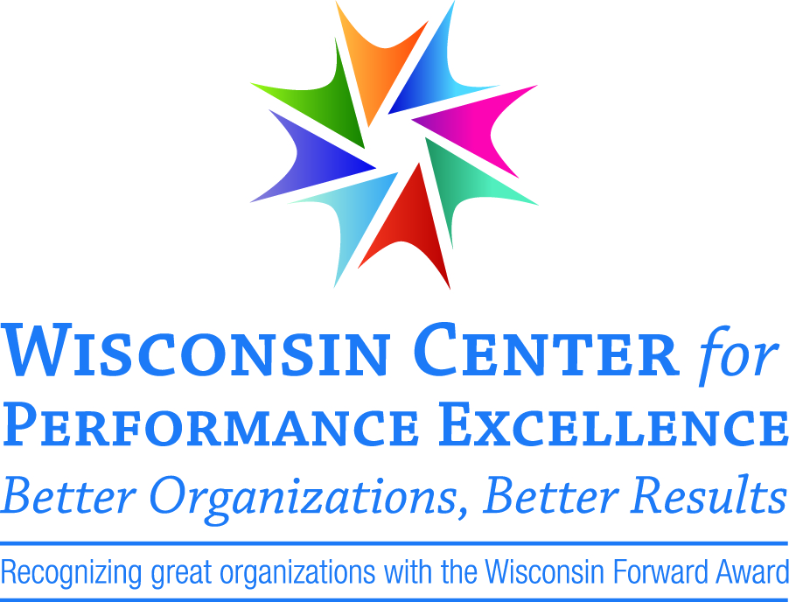

2909 Landmark Place, Suite 300 Madison, WI 53713
(608) 663-5300 www.wisquality.org
info@wisquality.org

